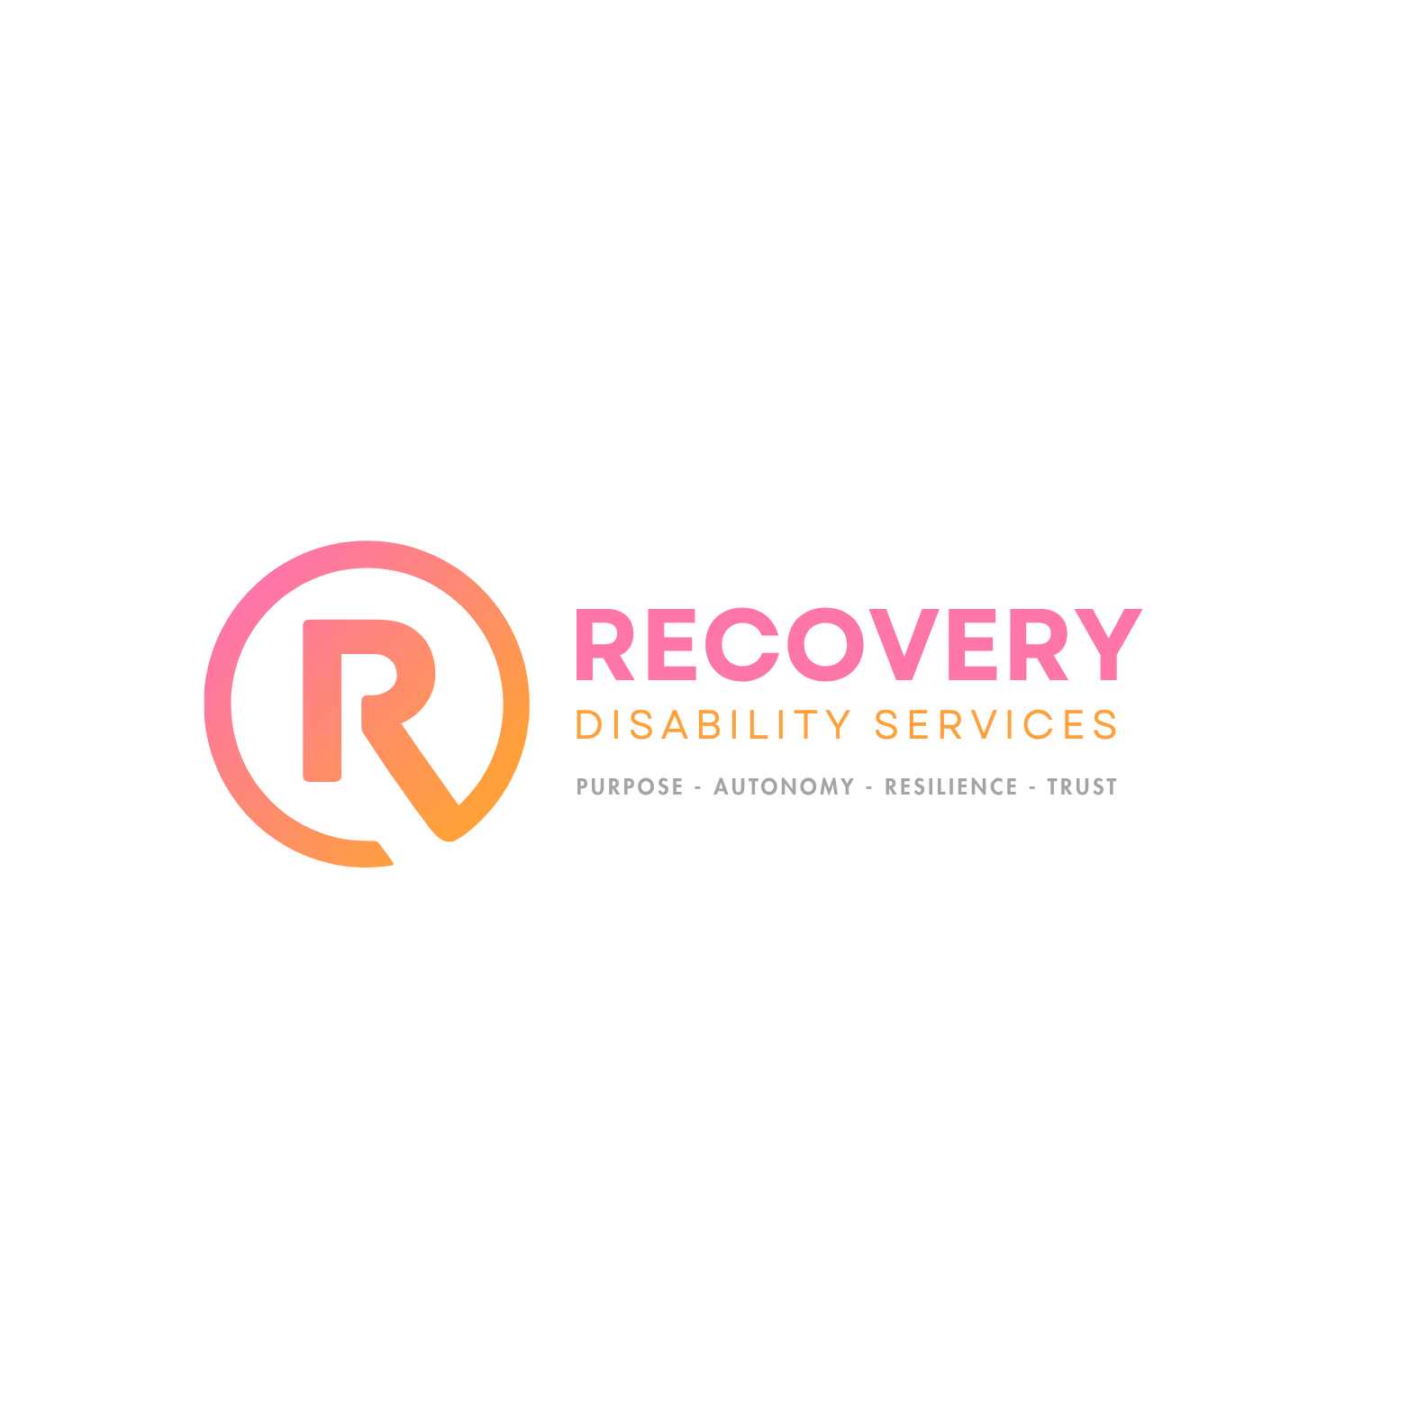
CAPABILITY STATEMENT
PURPOSE · AUTONOMY · RESILIENCE · TRUST

Specialist disability support across NSW and QLD

About Us
Recovery Disability Services is an NDIS-registered specialist disability provider operating across New South Wales and Queensland. Established 1 July 2025 under the direction of Dieu Merci James, we deliver purpose-built accommodation, supported independent living, community participation, and short-term accommodation — all grounded in a single promise: help people move forward.
Our Mission
To serve participants and their families with dedication, skill, and compassion — providing specialist disability supports that restore independence, strengthen resilience, and help people build a life of their own choosing.
Our Vision
A community where every person with disability has the home, the support, and the agency to move forward on their own terms.
Our Values
Purpose | Every support is goal-led. We work toward something, not just alongside.
Autonomy | Your choices, your voice, your life. We support — we don’t direct.
Resilience | Capability that lasts beyond our shift. Progress that compounds.
Trust | NDIS-registered, compliant, transparent. What we promise, we deliver.
Our Services
Specialist Disability Accommodation (SDA)
Purpose-built and modified homes for eligible participants with extreme functional impairment or very high support needs. Our SDA properties are matched to lifestyle, location, and compatibility. New vacancies available June 2026 across NSW and QLD.
Supported Independent Living (SIL)
24/7, overnight, or drop-in support delivered in your home. We pair you with a consistent team that knows your routine, goals, and preferences — so support feels like partnership, not oversight.
Community Access
Participation support for social, recreational, educational, and vocational life. We plan around your goals, handle the logistics, and back you until the support becomes independence.
Short-Term Accommodation & Respite (STA)
Planned respite, emergency stays, and transition support in safe, fully-supported settings — for families needing a break, participants trialling independence, or anyone needing a short-term base.
Why Recovery Disability Services
- Registered NDIS provider — compliant with Quality & Safeguards Commission standards
- Fully insured — public liability, professional indemnity, workers compensation
- Dual-state footprint — offices and operations in NSW and QLD
- Direct access to leadership — QLD State Manager available to support coordinators
- Responsive referrals — acknowledged within 24 business hours
- Goal-led support — every plan ties to measurable participant outcomes
Make a Referral
We welcome referrals from Support Coordinators, LACs, families, hospital discharge teams, and self-referring participants.
The fastest path: call us on 02 7233 4745, or submit a Request a Call Back at recoveryds.com.au. We respond within one business day with next steps, availability, and a no-obligation conversation about fit.
Contact
Director | Dieu Merci James
Phone | 02 7233 4745
Website | recoveryds.com.au
QLD Office | 23 Ryan Road, Redbank Plains QLD 4301
NSW Office | 5 Navelina Street, Gables NSW
Credentials
ABN | 95 680 614 411
NDIS Registration # | [to be added]
Established | 1 July 2025
Insurance | Fully insured

Forward, together.

